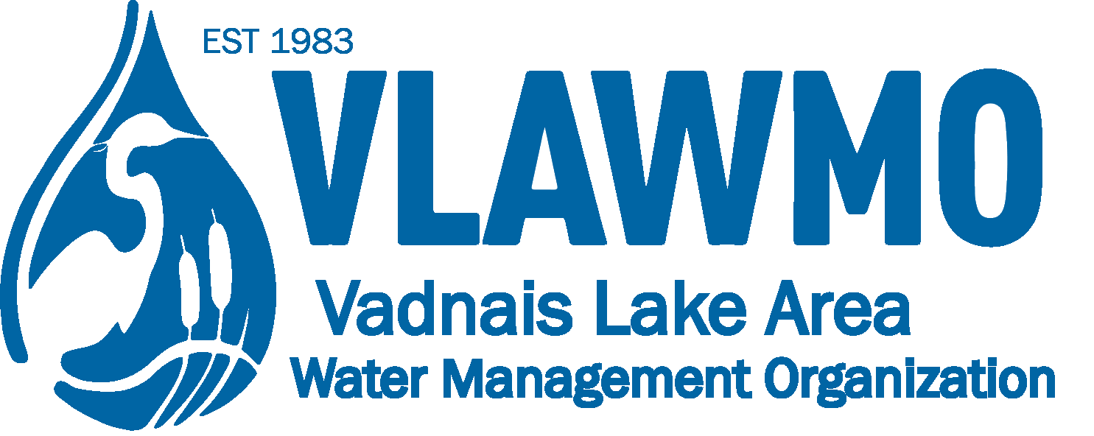

Watershed Steward Award Nomination

Nominee name and affiliation: Volunteer, resident, congregation, home/lake owner’s association, community group/club, etc.

Project(s): Ex. “BMP installation, business partnership event, volunteer recruitment event.” Include the goals of the effort, location, and nearby waterbody if applicable.

Time duration: Start of project to end of project (mo/yr) or an estimate of hours dedicated to the effort (prep, implementation, meetings, etc.)

Quote or summary statement: Based on the memory or experience of the effort, what’s the “take-home” summary that the community should hear about this individual/team and their effort? Are there any additional notable skills, dedication, attention to detail, or creative applications?

