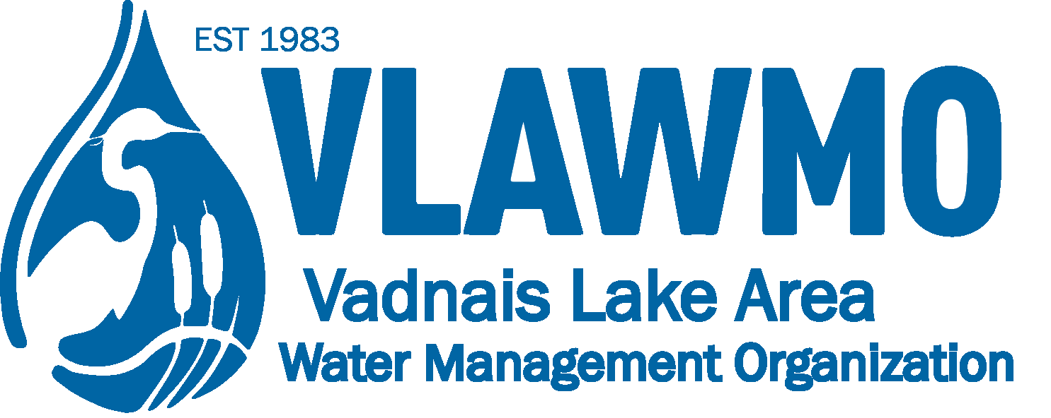

Watershed Partner Award Nomination

Nominee name and affiliation: Volunteer, resident, congregation, home/lake owner’s association, community group/club, etc.

Project(s): Ex. “BMP installation, project partnership, volunteer event.” Include the goals of the effort, location, and nearby waterbody if applicable.

Time duration: Estimate of time spent working on projects listed above.

Quote or summary statement: Based your the memory or experience of the effort, what’s the “take-home” summary that describes how the community and watershed benefit? If there are any additional skills applied, networking examples, problem solving, cross-disciplinary strategies, or creative applications please also describe them to your best ability.

